OxPal Trauma Series Workbook
2025


Contents

Introduction – page 3

ATLS – page 4

Abdominal/Pelvic Trauma – page 7

Cardiothoracic Trauma – page 9

Vascular Trauma – page 15

Neurological Trauma – page 19

Neck Trauma – page 21

Soft Tissue Trauma – page 22

Introduction

Welcome to the OxPal Trauma Series Workbook!

This workbook has been designed to supplement the lecture series course. It provides a range of cases and accompanying multiple choice questions which will hopefully be useful for solidifying the content in the course. These have kindly been produced by a few of the lecturers on the course.

If you have any questions about the workbook or any of the questions please just get in contact with Carla (carla.handford@gtc.ox.ac.uk).

Thank you!

Advanced trauma life support (ATLS)

Case 1

A 10-year-old girl is brought in after being struck by a car. She is crying. She is accompanied by her mother who states that she has no past medical history. She is placed on the monitors on arrival and a cervical collar is placed. Her vital signs are as follows: BP 90/45, P 120, RR 30, oxygen saturation is 95% .

What is the first step in the Primary Evaluation of this patient?
- Assess the airway
- Listen to her breath sounds
- Insert two peripheral IVs
- Place a pelvic binder
- Obtain radiographic imaging

Her airway is intact and auscultation of her lungs reveals decreased breath sounds to the right lung field. She is now in respiratory distress. She has tracheal deviation to the left side. Her vitals are checked again and are as follows: BP 60/40, P 130, RR 35, Oxygen saturation 80%. What is the next best step in the evaluation of this patient?
- Order blood transfusion
- Order Chest Xray
- Order CT scan Chest
- Insert R chest tube
- Intubation

Her vital signs are now 95/50, P 110, RR 25, oxygen saturation 95%. On secondary survey, she has bruising over her abdomen with some distention. Her pelvis is stable to lateral and anterior compression. Her spine exam shows no step-off abnormalities or tenderness. What is the next best step in the management of this patient?

- Consult general surgery
- Order blood transfusion
- Order CT scan of chest
- Obtain FAST ultrasound
- Admission

More MCQs:

- Which of the following below is the correct components and typical sequence of the Primary Survey of a trauma patient?
  - B-Breathing, A-Airway, C-Imaging, D-history, E- Exposure
  - A-Airway, B-Breathing, C- Circulation, D- Disability, E-Exposure
  - FAST exam, Blood, Airway, Disability.
  - D-Disability, C-Circulation, B-Breathing, A-Airway
  - C-circulation, D-disability, E-exposure, A-Airway, B-Breathing

- A 7-month-old child is brought in to the ED after sustaining a fall. The infant has multiple facial injuries and is not responsive and is in respiratory distress. The oxygen saturation is falling despite bag mask ventilation. Repeated attempts at orotracheal intubation are unsuccessful. What are is the most appropriate next procedure to perform next?
  - Attempt intubation again.
  - Attempt nasotracheal intubation.
  - Surgical cricothyroidotomy.
  - Apply non-rebreather mask.
  - Perform needle cricothyroidotomy with jet insufflation.

- Which of the following is an adjunct to the Primary Survey?
  - Intubation.
  - CT scan imaging.
  - Operative intervention.
  - Obtaining ECG.
  - Transfer to other hospital.

- A 40-year-old male female presents after severe car crash in which she was the passenger. She is transported to a small field hospital with no surgical capabilities. Her GCS score is 5. Endotracheal intubation is performed. Her vital signs are as follows: 120/65, P 95, RR 18, Oxygen saturation 100%. She is getting prepared to be transferred to a larger hospital for definitive care. Which of the following is the best test to perform prior to her transfer?
  - CT scan of her chest and abdomen.
  - Transfusion of blood
  - Lateral spine x-rays
  - Chest X-ray
  - MRI of her brain

- A 17-year-old female is brought in after sustaining a fall from a third story building. She complains of inability to move her lower extremities. Her BP is 75/40, P 80, RR 20, Oxygen saturation is 95%. Her FAST ultrasound exam is negative for any free fluid. She has no abdominal pain. She has no injuries to her extremities. Her breath sounds are equal and she is not in any respiratory distress. What is the next best step in management of her hypotension?
  - Start vasopressors
  - Transfuse blood
  - Bolus 2 L of normal saline
  - Administer dexamethasone
  - Insert central line catheter.

- What does FAST stand for?
  - Fast Airway Stat Test
  - Focused Airway Sensitivity Test
  - Focused Assessment with Sonography in Trauma
  - Focused Airway Stat Test

- What are the views of the FAST exam?
  - Lung view, mid abdomen, posterior view.
  - Subxiphoid window, right upper quadrant, left upper quadrant, pelvis.
  - Right and left lung view, subxiphoid, mid abdomen.
  - Carotid view, femoral view, subxiphoid view, axillary view.
  - Subxiphoid window, right upper quadrant, right lower quadrant, pelvis.

Abdominal/pelvic Trauma
MCQs:

- A 25-year-old women is brought in to the ED after nearby blast injury. She is lethargic but responding to questions. Her BP is 95/65, Pulse 130, RR 33, Oxygen saturation 95%. On examination, she has a puncture wound to her mid anterior abdomen. Her FAST exam shows fluid in the right upper quadrant (Morrison’s pouch). She has received one L of Normal Saline. What is the next step in management?
  - Obtain CT scan.
  - Perform gynecologic exam.
  - Go to Operating Room for exploratory laparotomy
  - Obtain and wait for lab work (CBC, BMP).
  - Admit the patient to ICU.

- A 25-year-old male presents to the ED after being struck by a vehicle while crossing the street. He is awake but lethargic. His BP is 85/60, P 120, RR 35, Oxygen saturation 95%. His FAST exam is positive and he is complaining of abdominal pain. His abdomen has bruising on the left side. One liter of Normal Saline has already been given with minimal improvement of his vital signs. He has two peripheral 18G IVs. What is the next best step in management?
  - Infuse a second liter of saline
  - Transfuse blood
  - Give hypertonic saline
  - Insert a central line.
  - Obtain Chest XRAY.

- A 65-year-old female is brought in to the hospital after being struck by a car. She is confused and her eyes do open with painful stimuli. She is moving around and localizing to painful stimuli with her upper extremities. Her blood pressure is 85/60, pulse 110, RR 30, oxygen saturation 95%. A FAST exam is performed and the right upper abdomen image is shown below:
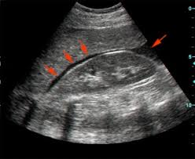

Besides beginning blood transfusion, what is the next best step in management?
- Intubate the patient
- Infuse crystalloid fluid
- Transport the patient to the operating room
- Obtain CT scan
- Admit to the ICU

- A patient sustains severe poly-trauma after blast injury. She sustains multiple injuries and is in the operating room undergoing exploratory laparotomy. She is being massively transfused blood due to massive hemorrhage. Which below represents the most optimal resuscitation?
  - 2 units packed RBCs, 5 units Fresh frozen plasma (FFP), 1 pack of platelets
  - 4 units of packed RBCs, 4 units of FFP, 1 pack of platelets
  - 5 L of crystalloid, 2 units of packed RBCs, 1 unit of FFP
  - 2 L of crystalloid, 3 units of packed RBCs, 1 unit of FFP
  - 2L of crystalloid, 8 units of packed RBC, 1 unit of FFP

- A 22-year-old patient presents with multiple shrapnel injuries to his chest and abdomen. His blood pressure is 80/60, pulse is 130, RR 30, oxygen saturation 90%. Massive transfusion of blood products is initiated. Which of the following is the best option for access in order to massively transfuse the patient?
  - One intraosseous catheter (IO)
  - Two large bore (16-18G) peripheral IVs
  - One triple lumen central line (18G)
  - One 22G peripheral IV
  - Saphenous vein cutdown with insertion of one 20G IV

Cardiothoracic Trauma
Case 1

A 25-year-old man is brought to the emergency room after sustaining gun shot wound to the torso region. He is awake and alert. He is diaphoretic. His vital signs are as follows: BP 110/70, P 120, RR 35, Oxygen saturation 92%. His breath sounds are diminished in the R side. On examination, a single hole is visible in the left lateral chest wall. No other injuries are noted. He has two 18G peripheral IVs.

- What is the next best step in management?
  - Intubate the patient
  - Order blood transfusion
  - Insert central line
  - Obtain chest xray
  - Obtain CT scan of abdomen

- His Chest Xray is shown below: what is the next best step in management?

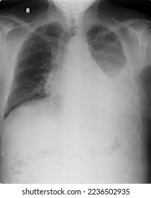
  - Intubate the patient
  - Insert L sided chest tube
  - Insert R sided chest tube
  - Obtain CT scan of chest
  - Order blood transfusion

- The patient also undergoes a FAST exam which shows fluid around the heart (see below) as well as fluid around the liver (see below). His vital signs are as follows: BP 95/60, P 120, RR 35, oxygen saturation 95%
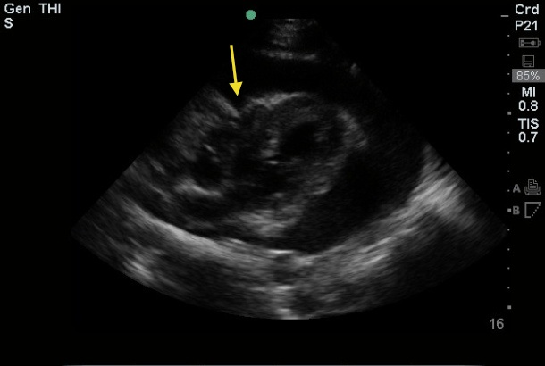

What is the next best step in management?
- Obtain CT chest/abdomen
- Order blood transfusion
- Start vasopressors
- Proceed to the operating room for median sternotomy and exploratory laparotomy
- Admission to the ICU.

Case 2
A 19-year-old male arrives with a single penetrating injury to the left chest, medial to the left nipple. He is awake, alert, conversant and has bilateral breath sounds.

Question 1: Which of the following is a consideration for his assessment/resuscitation?
- He is hemodynamically stable and thus needs no further workup.
- He would benefit from fluid resuscitation with 5% albumin.
- Intravenous access in the left upper extremity should be avoided.
- Lower extremity intravenous access is preferred.

Question 2: Which of the following is an anatomic border of the “cardiac box?”
- The nipples laterally
- The scapulae laterally
- The clavicles superiorly
- The inferior costal margin
- All of the above

Question 3: Which of the following imaging modalities is adequate for evaluation of penetrating cardiac injury?
- Chest XR
- CT Chest
- Echocardiography/ultrasound
- Both B and C

Case 3
A 3-year-old female presents after a motor-vehicle collision. She was a restrained backseat passenger in a high-speed collision.

Question 1: If her GCS is 15 and her primary and secondary exam have no notable findings, which of the following imaging tests is indicated:
- CT Head
- CT Neck
- CT Abdomen/Pelvis
- Chest X-ray

Question 2: The same patient was found to have a seat-belt sign. CT Abdomen/Pelvis was obtained and demonstrated a grade 4 splenic laceration with active contrast extravasation. Vital signs remain stable. What is the next best step in management?
- Laparotomy, splenectomy
- Transfusion of blood
- Discharge home
- Observation, serial examination

Question 3: Which of the following is an anatomic consideration of blunt trauma in children as compared to adults?
- The rib case is more brittle, and rib fractures are more common
- The bladder sits lower in the pelvis as compared to an adult
- The abdominal wall is thinner and thus the viscera are more susceptible to trauma
- Children are little adults and there is no difference in anatomic considerations

More MCQs:

- An 18-year-old male presents to the ED after gun shot wound. He is in respiratory distress. He is able to answer questions. His vitals are as follows: BP 85/60, Pulse 120, RR 35, oxygen saturation 89%. On examination there is a single hole in the left chest. Auscultation of the lungs reveals diminished breath sounds in the left lung field. What is the best next step in management?
  - Insert IV and start blood
  - Insert IV and infuse crystalloid fluids
  - Insert chest tube in the left chest.
  - Insert chest tube in the right chest
  - Obtain FAST exam.

- A 22-year-old female is brought in to the hospital after falling down the stairs. She complains of L sided chest pain. Her breath sounds are diminished bilaterally. Her vital signs are normal. A Chest X ray is obtained and is shown below:
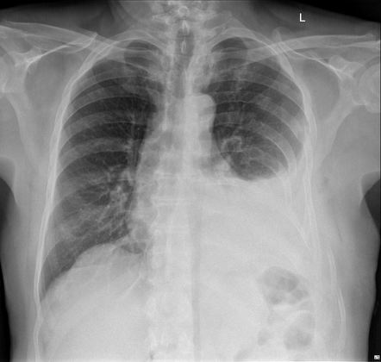
What is the diagnosis?
- Tension pneumothorax
- Simple pneumothorax
- Hemothorax
- Normal Chest Xray
- Cardiac tamponade

- A 55-year-old man is brought to the hospital after a motor vehicle collision. He is short of breath and has chest pain. His vital signs are 135/70, P 110, RR 28, Oxygen saturation 92%. His Chest Xray is shown below:
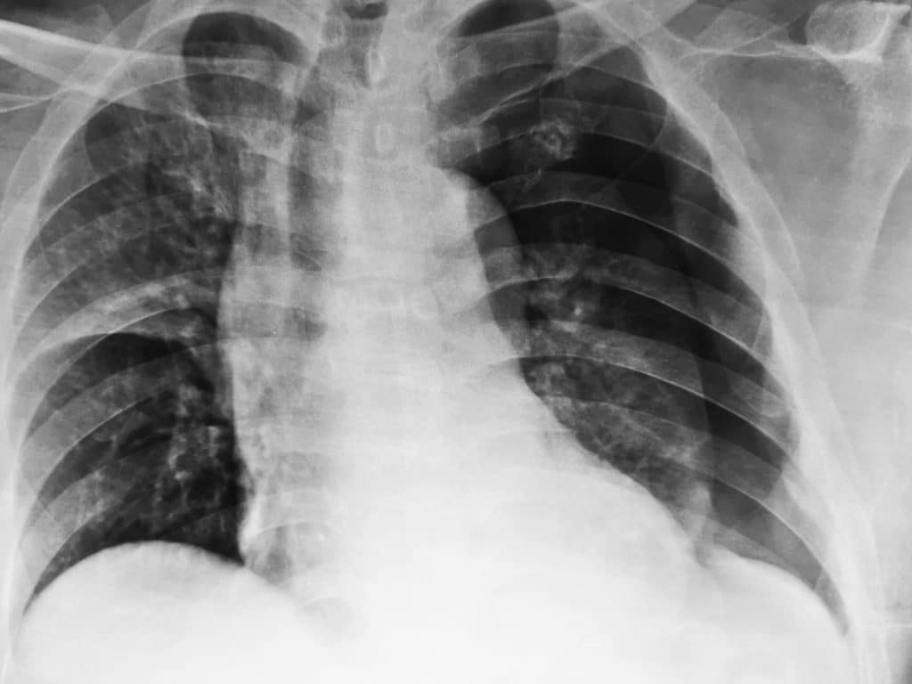

What is the correct diagnosis?

- Tension pneumothorax
- Simple pneumothorax of left side
- Simple pneumothorax of right side
- Hemothorax of left side
- Hemothorax of right side

4. A 16-year-old girl is brought into the hospital after a missile strike in which she was thrown onto her R side. She is in respiratory distress. Her beath sounds are diminished in the R side. Her vitals are as follows: BP 85/50, P 130, RR 35, Oxygen saturation 90%. What is the next best step in management?
- Obtain Chest Xray
- Finger thoracostomy to the R chest.
- Obtain CT scan of the chest
- Obtain EKG
- Consult thoracic surgery

5.A 22-year-old male is brought in to the Emergency room after sustaining a gunshot wound. He has shortness of breath and an injury to the left chest wall is noted. He was speaking normally and his vitals were stable. A chest tube was inserted into the L chest. On insertion of the chest tube, greater than 2 L of blood was evacuated and the patient became hypotensive. What is the next best step in management?
  - Intubate the patient.
  - Transfuse crystalloid.
  - Obtain CT scan of the chest
  - Transfuse blood and prepare the OR for thoracotomy.
  - Obtain a Chest Xray.

- A 30-year-old male is brought in after fall from a ladder. He is complaining of chest pain. His vitals are 120/90, pulse 96, RR 30, Oxygen saturation 95%. He is at a facility with no admitting capabilities and will need transfer to a higher level of care. He is taken to CT scan of his chest which is shown below:
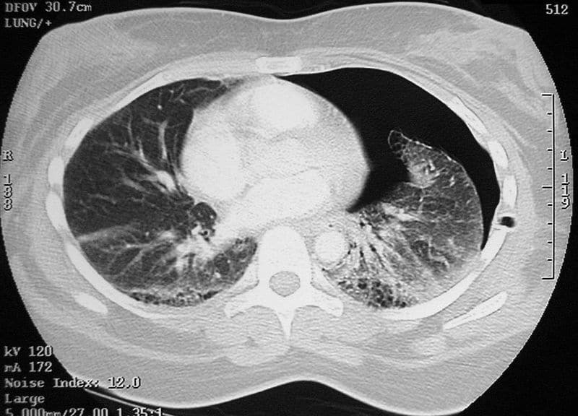
What is the next best step in management?
- Insert chest tube
- Intubation
- Pain control
- Discharge from facility
- Proceed with transfer to higher level of care.

- A 20-year-old female is brought in with gun shot wound to the left chest. Her chest x-ray demonstrates Left hemothorax. Where is the optimal insertion location of a chest tube?
  - 2nd intercostal space mid clavicular line
  - 7th intercostal space mid axillary line
  - 5th intercostal space mid axillary line
  - 5th intercostal space mid clavicular line
  - 2nd intercostal space mid axillary line

Vascular trauma
Case 1
An 18-year-old man is brought into the ED after motor vehicle accident. The hospital has CT and Surgical capabilities. He is complaining of Left knee pain. He was the passenger of the vehicle. He was not wearing a seatbelt. The vehicle sustained significant damage to the front. He is alert and awake. His GCS is 15. His vital signs are 130/65, P 110, RR 30, oxygen saturation 97%. On exam he has a swollen knee with bruising along his thigh with significant swelling. His pulses are intact in bilateral lower extremities. An Xray of the left knee shows a distal femur fracture.
- What is the next best step in the management of this patient?
  - Obtain CT angiogram of left leg
  - Obtain compartment pressures of left leg.
  - Obtain ankle-brachial index (ABI)
  - Consult orthopedic surgery
  - Consult vascular surgery
- Which of the following describes the best method to obtain an ABI?
  - Doppler pressure of dorsalis pedis artery of affected limb over doppler pressure of unaffected arm (brachial artery).
  - Doppler pressure of femoral artery of affected limb over doppler of unaffected arm (brachial artery)
  - Doppler pressure of dorsalis pedis artery of unaffected limb over doppler of unaffected arm (brachial artery).
  - Doppler of one brachial artery compared to the doppler pressure of the contralateral arm.
- The ABI is performed of the injured leg and the ABI is 0.7. What is the next best step in diagnosis and management?
  - Obtain CT angiogram of the left leg.
  - Obtain compartment pressures of the left leg.
  - Consult orthopedic surgery
  - Consult vascular surgery
  - Proceed to operating room.

Case 2
A 25-year-old female presents with multiple injuries sustained after car crash. She has a large bruise overlying her right mid-thigh but there is no active bleeding. She is awake and alert. She did not strike her head in the crash. Her GCS is 15. She is complaining of right leg pain and mild back pain. Her vitals are as follows: 120/60, P 95, RR 30, Oxygen saturation 99%. She has no significant medical history and is on no home medications. Secondary survey demonstrates no significant findings other than significantly swollen R thigh.

- Which of the following is most concerning on exam and requires immediate intervention?
  - Presence of femur fracture
  - Significant pain
  - Numbness in her foot
  - Tachycardia
  - Expanding hematoma of the thigh
- On pulse exam, it is noted that the right foot does not have pulses. What is the next step in management?
  - STAT vascular surgery consult
  - MRI leg
  - CT angiogram of leg
  - Xray of leg
  - Tourniquet to the right leg.
- What imaging would be most beneficial to obtain prior to the patient going to the operating room?
  - Chest x-ray
  - Lateral back x-rays
  - CT scan of right leg
  - Xray of R thigh
  - Pelvis x-ray

More MCQs:

- A 10-year-old presents to the ED after blast injury. He is lethargic and difficult to arouse. He is covered in dirt and blood. Vitals are 65/40, P 140, RR 35, oxygen saturation 90%. There is a 3cm puncture in his R groin that is bleeding profusely. What is the best next step in management?
  - Order blood transfusion
  - Apply tourniquet to right thigh.
  - Apply direct manual pressure to the groin wound.
  - Consult vascular surgery
  - Apply compressive wrap dressing to the right lower extremity.

- A 22-year-old man is stabbed in the L mid-thigh. Bright red pulsatile blood was noted to be coming from the wound. A tourniquet is applied on the thigh above the wound with good control of the bleeding. What is the next step in definitive management?
  - Obtain CT angiogram of L lower extremity
  - Obtain x-rays
  - Order blood transfusion
  - Check doppler study of lower extremity
  - Proceed to the OR for exploration.

- Which of following is an example of a “hard sign” in vascular trauma.
  - Continuous oozing from wound
  - Large hematoma over wound
  - Loss of pulses in affected limb
  - Pain
  - Need for blood transfusion

- A 25-year-old female is brought to the hospital after a tree branch fell onto her extremity. She is complaining of pain and tenderness over her Right lower extremity. She has sensation of her lower extremity. There is pain and swelling overlying her thigh. What finding below would mandate immediate operative exploration?
  - Expanding hematoma with loss of pulses
  - Numbness of her foot
  - Severe pain
  - Need for blood transfusion
  - Bruising and hematoma

- A 40-year-old female presents with a large 10cm deep laceration to her R thigh. She is hemodynamically normal. Her distal peripheral pulses are intact and are easily palpable. She has no neurologic deficits in any of her extremities. The wound is washed out with warm saline and inspected revealing lacerated muscle with no bone visible. There is however continued bleeding from the muscle which is dark and non-pulsatile. Which of the following is the best method to achieve hemostasis in this patient?
  - Apply tourniquet to the right lower extremity. Attempt closure in 6 hours.
  - Close the wound with staples.
  - Do not close wound and apply dressing over the wound.
  - Pack the wound with dampened gauze and wrap the thigh. Remove packing in 12 hours and attempt closure.
  - Pack the wound and discharge the patient.

- A 12-year-old boy presents with penetrating injury to the right mid arm. His dressing is saturated with blood. The dressing is taken down and pulsatile blood can be seen from a medial mid arm wound near his brachial artery. Which of the following is the best course of action?
  - Rewrap the arm and obtain CT imaging.
  - Apply tourniquet and admit the patient.
  - Apply tourniquet and consult vascular surgery.
  - Apply tourniquet and obtain CT angiogram.
  - Close the wound with sutures.

- A 35-year-old man sustains a blast injury to his thigh. Bleeding is controlled with tourniquet. He is diaphoretic and sweating. He is confused but able to say his name. His vitals are as follows: 80/60, P 120, RR 30, Oxygen saturation 92%. Which of the following demonstrates that he is in hemorrhagic shock?
  - Tachycardia
  - Tachypnea
  - Hypotension
  - Confusion
  - Cool skin

Neurological trauma
Case 1

A 60-year-old male is brought in after sustaining a fall. He has a past medical history of atrial fibrillation, diabetes, and coronary artery disease. He is on Coumadin (Warfarin) for his atrial fibrillation. He has evidence of head trauma. His vital signs are 145/70, P 98, R 25, Oxygen saturation is 98%. He does not open his eyes to painful stimuli, he has abnormal extension of his upper extremities to painful stimuli and is only saying incomprehensible sounds. He has a 4cm laceration to his R scalp with some bleeding which is controlled with manual pressure. He has no other visible signs of trauma. Two peripheral IVs are inserted.

- What is the patients Glasgow Coma Scale Score?
  - 10
  - 12
  - 5
  - 8
  - 6

- What is the next best step in management?
  - Administer non-rebreather oxygen mask
  - Administer anti-seizure prophylaxis
  - Obtain CT scan of his brain
  - Intubation
  - Admission to ICU
- The patient is subsequently taken to CT scan and a large R sided subdural hematoma is demonstrated (see below). What is the most important consideration immediately for this type of injury?
  - Initiating nutrition on day of injury
  - Inserting an intraventricular drain
  - Avoiding hypotension and hypoxia
  - Starting anti-seizure prophylaxis
  - Early ambulation

More MCQs:

- A 65-year-old M arrives to the ED after sustaining blunt trauma to the head. The scalp was bleeding significantly and was controlled temporarily with pressure dressing. The patient is moaning and gurgling sounds are heard from his airway. He is not responsive to stimuli. His BP is 120/60. Pulse is 85. RR 25. His oxygen saturation is 92%. What is the next step in the management?
  - Insert IVs
  - Close the scalp laceration.
  - Perform a neurological exam.
  - Prepare to intubate the patient.
  - Take the patient to CT scan.

- A 35-year-old female is brought in to the ED after falling from a second story building. She landed on her head. She complains of neck pain and cannot move her lower extremities. She is able to speak clearly and her GCS is 14. Breath sounds are equal bilaterally. Her vitals are as follows: 135/80, P 65, RR 25, Oxygen saturation 97%. What is the next step?
    - Intubate the patient
    - Administer blood product
    - Apply cervical collar and maintain spine immobilization
    - FAST exam.
    - CT scan

3.A 56-year-old male is brought to the hospital after sustaining a car crash. He has evidence of head trauma. He appears to be in distress. His eyes open to painful stimuli. He is moaning and making incoherent sounds. He is has abnormal flexion of his upper extremities to painful stimuli. Which of the following below represents his GCS score (Glasgow Coma Scale)?
    - 8
    - 6
    - 7
    - 3
    - 10

- For the above patient, what is the next best step in management?
  - Transfuse blood.
  - Infuse crystalloid solution.
  - Infuse hypertonic saline solution.
  - Obtain CT scan.
  - Prepare to intubate the patient.

- A 65-year-old male is brought in to the ED after sustaining a fall. He struck his head on the pavement. He is alert and talking. He is hemodynamically normal. He has loss of consciousness. He takes blood thinners for his atrial fibrillation. He has a large 4cm laceration in his scalp that is bleeding profusely. The laceration can be seen despite his hair around it. The laceration appears to be easily reapproximated. What is the best method of the choices below for wound closure of this scalp laceration?
  - 5-0 nylon suture in a running fashion
  - 5-0 nylon suture in an interrupted fashion
  - Close laceration with skin stapler
  - 3-0 vicryl in a subcuticular running fashion
  - 5-0 monocryl in a subcuticular running fashion
Neck trauma
Case 1
A 7-year-old male suffers a stab wound to the neck with a pencil. He arrives to the trauma bay in extremis.

Question 1: If there is concern for airway injury, what is the most appropriate method to secure a surgical airway?
- Surgical cricothyroidotomy
- Tracheostomy
- Needle cricothyroidotomy
- Sternotomy and central access to the trachea

Question 2: After his airway is secured, what is the most appropriate imaging to evaluate the neck’s vascular structures?
- CT scan of the neck with contrast
- XR of the neck
- Ultrasound of the neck
- Physical examination is sufficient to evaluate vascular injury

Question 3: In the operating room, the carotid injury is repaired but the internal jugular vein is nearly transected and bleeding. The patient is cold and coagulopathic. What is the next best step?
- The internal jugular should be repaired by mobilization and primary repaired.
- The internal jugular should be bypassed, either with vein harvested from the patient or cryo-preserved vein.
- The internal jugular vein should be ligated.
- The internal jugular vein should be sewn to the carotid artery to maintain patency.

Soft tissue trauma
Case 1
A 45-year-old female is brought to the ED after sustaining injuries to her lower extremities after a wall collapsed on her. She was extricated from the rubble and brought to the ED. She is lethargic but is complaining of lower extremity pain. Her vitals are as follows 130/70, P 100, RR 25, oxygen saturation is 95%. On examination she has bilateral thigh wounds which are large and measure approximately 10 cm long by 3 cm wide bilaterally. Soft tissue and muscle can be visible from both wounds. Bleeding is controlled with packing the wounds. Her pulse exam demonstrates intact dorsalis pedis and posterior tibial artery pulses bilaterally. She is able to move both of her extremities.
- After the primary and secondary survey is complete what is the next best step?
  - Close the lacerations with sutures
  - Obtain x-ray films of bilateral lower extremities
  - Obtain CT angiogram of bilateral lower extremities
  - Consult orthopedic surgery

- There are no fractures noted on imaging. The dressings are taken down and the wounds are cleaned and washed with normal saline. However, there is continued oozing from the torn muscle on bilateral thighs which is pooling on the patient’s bed. Which of the following is a good option to control bleeding?
  - Inject the muscle with 1% lidocaine with epinephrine
  - Apply bilateral tourniquets
  - Attempt to suture the torn muscle
  - Close the skin of the wounds
  - Repack the wound with gauze and place compressive wrap on bilateral thighs.

- After 12 hours the dressings are taken down and the wounds are hemostatic. Which of the following represents a good method of closure of these wounds?
  - Closing the deep tissues with absorbable suture and approximating the skin loosely with staples.
  - Closing the deep tissues with non-absorbable suture and approximating the skin with absorbable suture.
  - Closing the deep tissues with non-absorbable suture and closing the skin with staples.
  - Closing the deep tissues with absorbable sutures and packing the skin and soft tissue with gauze.

Case 2
A 2-month-old female presents to the emergency room for fussiness. The mother states that the baby will not stop crying. On examination, there is bruising over the patient’s body.

Question 1: Which of the following is true?
- If the patient has a history of hemophilia, no further work up is required.
- This child should be evaluated for non-accidental trauma (child abuse).
- If the parents appear loving and concerned, non-accidental trauma is not on the differential diagnosis.
- It is normal for a 2-month-old female to have multiple bruises.

Question 2: Which of the following is necessary in the physical examination of a child for whom non-accidental trauma is suspected?
- Examination of the oral cavity for trauma
- Ophthalmologic evaluation
- Evaluation of all skin surfaces for trauma
- All of the above

Question 3: The child is found to have a femur fracture. Which of the following medical diseases must be ruled out?
- None – this finding is pathognomonic for non-accidental trauma
- Osteogenesis imperfecta
- Vitamin D deficiency
- Nieman Pick Syndrome

MCQs

- A 10-year-old child sustained a blast injury with significant lacerations from shrapnel. The child is lethargic and moaning. He appears to be breathing normally and breath sounds are equal bilaterally. His eyes are open. Vital signs are as follows: BP 90/60, P 120, RR 35, oxygen saturation 94%. There is a significant amount of blood coming from a large R thigh wound which is just above his knee. What is the next best step in management?
  - Intubation
  - Apply tourniquet to the R upper thigh
  - Apply tourniquet to the R lower leg
  - FAST exam
  - Go to the operating room

